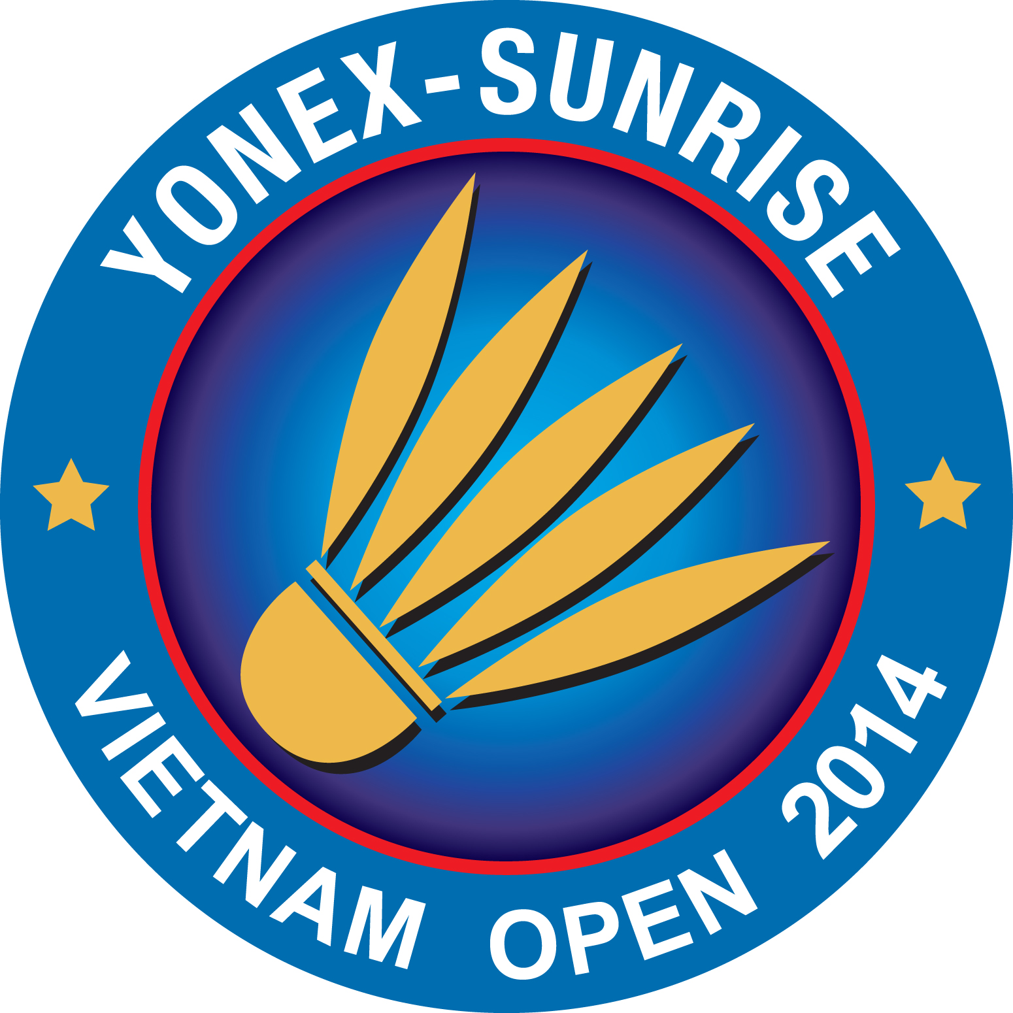

PLEASE RETURN TO email hcmba@vnn.vn ; huynhlienhcmc@vnn.vn
OR FAX ++ 84 8 38208773 NOT LATER THAN 15th August 2014.
Name of Member Association:
Contact Person:
PHONE NUMBER: | MOBILE NUMBER:
FAX NUMBER | E-MAIL

Arrival
Date | Time | Airport | Airline
 |  | HO CHI MINH TAN SON NHUT
Departure
Date | Time | Airport | Airline
 |  | HO CHI MINH TAN SON NHUT
Transportation will be arranger for your arrival and departure from PLEASE FILL UP.
and retune to the organize: huynhlienhcmc@vnn.vn ; hcmba@vnn.vn before August 15th ,2014

