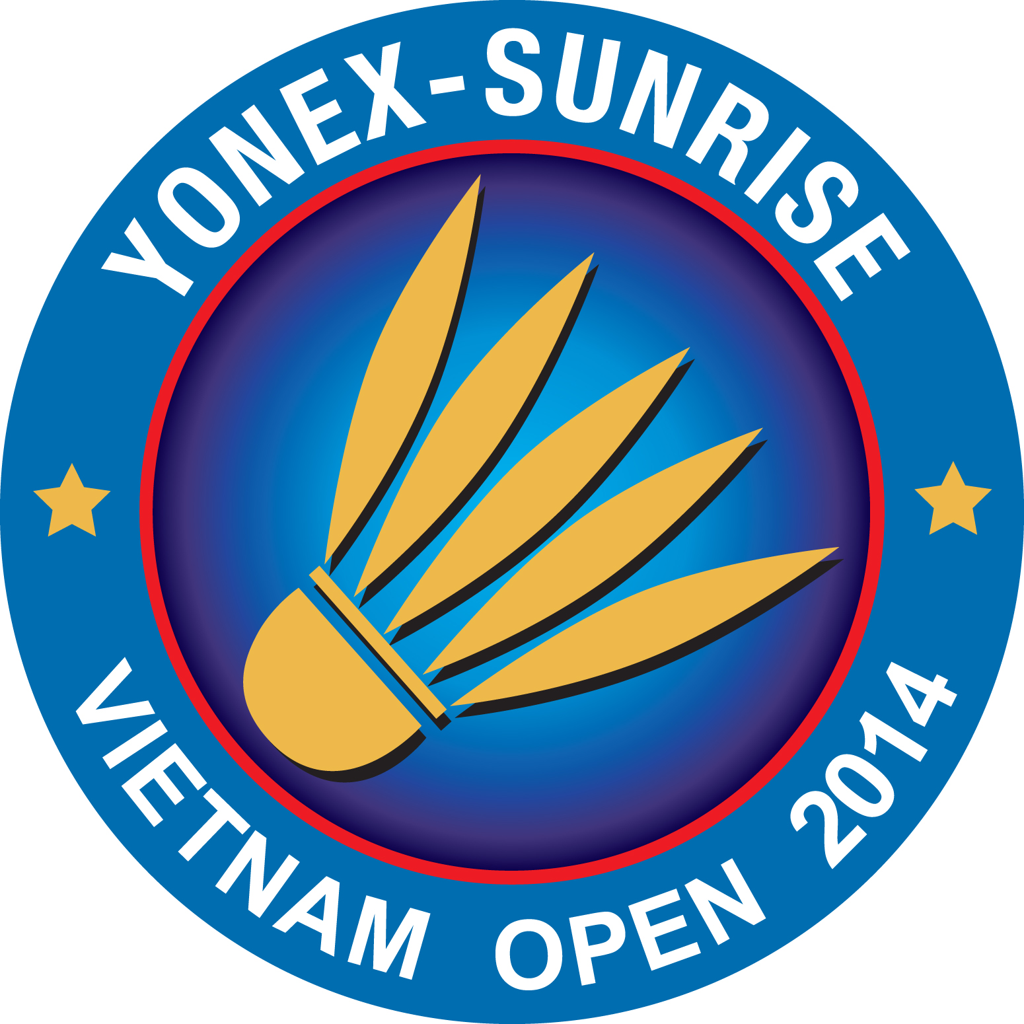
PLEASE RETURN TO email hcmba@vnn.vn ; huynhlienhcmc@vnn.vn
OR FAX ++ 84 8 38208773 NOT LATER THAN 9th August 2014.

Name of Member Association:
Contact Person:
PHONE NUMBER: | MOBILE NUMBER:
FAX NUMBER | E-MAIL

Name of Hotel:

ROOMING LIST
No. of room(s) | Type of room | Full Name | Check-in | Check-out
No. of room(s) | Single / Twin | Full Name | Check-in | Check-out

